June 2020

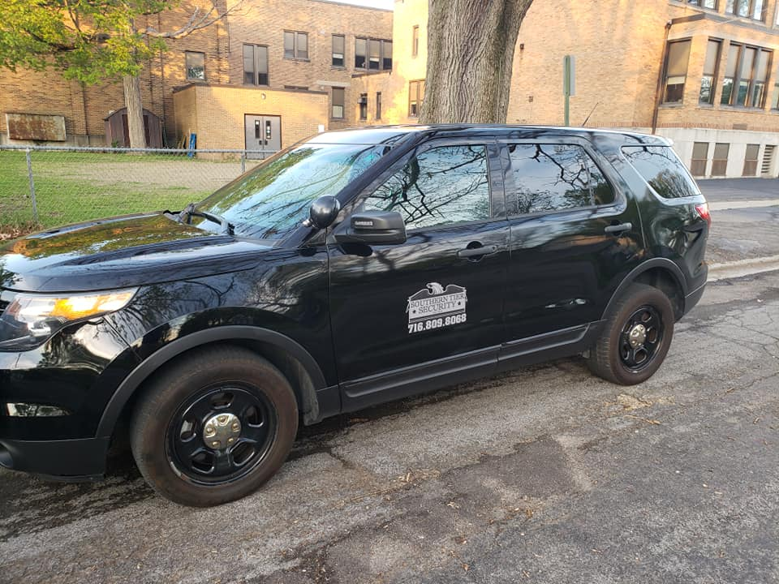
Southern Tier Security’s newest patrol vehicle

Anniversary’s
Brandon Hoffman 24th

Birthday’s
Max Nunes 10th
William Miller 10th
Jamie Rocque 14th
Michaela Schneider 18th
Zach Boardman 19th
Jeff Bush 20th
Steve Olsen 27th
Brandie Lippert 28th

Interesting fact…During The middle ages in Europe, watchmen were employed to look after valuables as well as observe and report any incoming attacks. Later on, in America they became known more predominately as night-watchmen before their title evolved to a more general and inclusive title such as security guard, private patrol officer, or security.
HAPPY FATHER’S DAY!!! June 21st

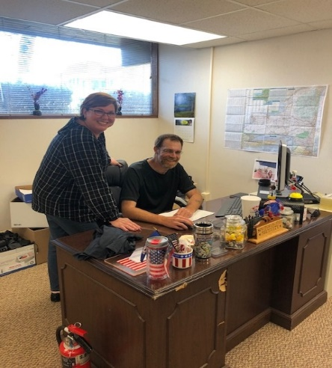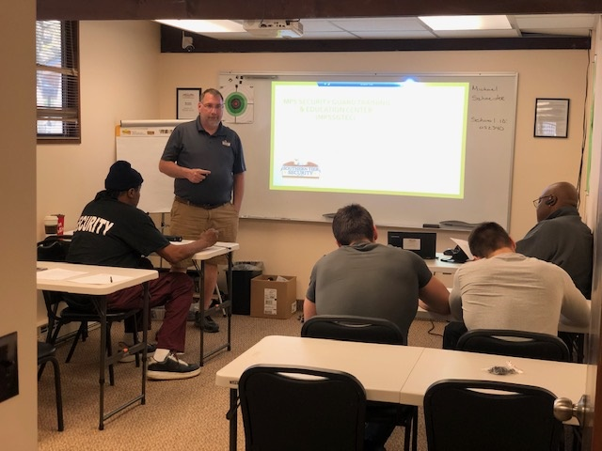
Jamie Rocque (HR) and Brian Teagarden (Operation Support Supervisor) hard at work  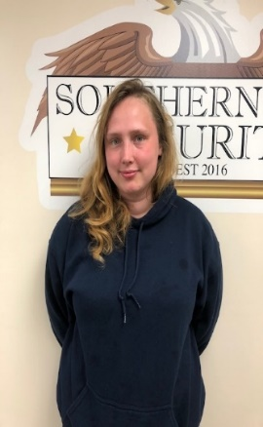 |  | 8 hour annual course being held in our new training room  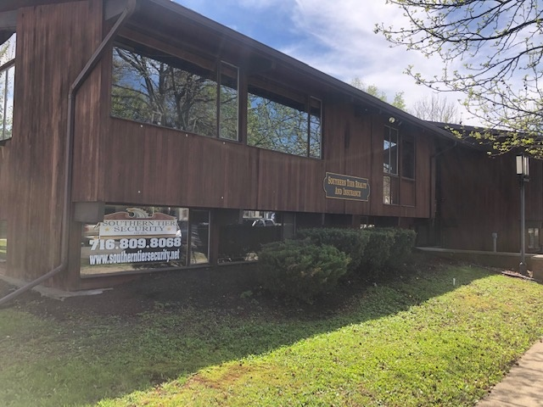
‘My name is Heather Chamberlain. I have lived in the Jamestown area all of my life. I have 3 children. I studied Criminal Justice at Bryant and Stratton. I have been a Security Guard for 3 years. “  2nd Addition |  | Southern Tier Security office in Olean
‘My name is Heather Chamberlain. I have lived in the Jamestown area all of my life. I have 3 children. I studied criminal justice at Brant and Stratton. I have been a Security Guard for 3 years.”

